DATA ACQUISITION AND CLEANING PROCESS

E-Commerce Sales and Customer Analytics

Internship: YuvaIntern – Virtual Data Analysis Intern
Week: 2 – Data Acquisition and Cleaning Process
Dataset: UCI Online Retail Dataset
Student: Moksha
Project: E-Commerce Sales and Customer Analytics

1. Introduction

Data acquisition and data cleaning are important stages of any data analysis project because the quality of the analysis depends heavily on the quality of the underlying data. The objective of this week's work was to acquire the dataset selected during Week 1, examine its structure and quality, identify data-quality problems, and prepare a reliable dataset for further analysis.

The project uses the Online Retail dataset from the UCI Machine Learning Repository. The dataset contains transactional information from a UK-based online retailer and includes information about invoices, products, quantities, prices, customers and countries.

The original dataset contained 541,909 transaction records and 8 columns. Python and Pandas were used to inspect, clean and transform the data. Several data-quality issues were identified, including duplicate records, cancelled invoices, negative quantities, non-positive prices and missing customer information.

The cleaning process was designed to remove invalid transaction records while preserving information that could be useful for future analysis.

2. Data Acquisition

2.1 Dataset Source

The dataset used for this project is the Online Retail Dataset from the UCI Machine Learning Repository.

The dataset contains transactional records for an online retailer between 1 December 2010 and 9 December 2011.

The original dataset contains the following fields:

Column| Description
InvoiceNo| Invoice or transaction number
StockCode| Product identification code
Description| Product description
Quantity| Number of products purchased
InvoiceDate| Date and time of transaction
UnitPrice| Price per product
CustomerID| Customer identification number
Country| Customer's country

The dataset was downloaded as an Excel file and loaded into Python using Pandas.

2.2 Data Loading Method

The Excel dataset was loaded using the "pandas.read_excel()" function.

The following Python libraries were used:

- Pandas – data loading, profiling and cleaning
- NumPy – numerical operations
- Scikit-learn – Min-Max normalization
- OpenPyXL – reading the Excel workbook

The raw dataset was kept unchanged so that the cleaned version could always be traced back to the original source.

3. Initial Data Profiling

After loading the dataset, several profiling checks were performed to understand its structure, completeness and integrity.

3.1 Dataset Dimensions

The initial dataset contained:

- Rows: 541,909
- Columns: 8

3.2 Missing Values

The initial missing-value analysis produced the following results:

Column| Missing Values
InvoiceNo| 0
StockCode| 0
Description| 1,454
Quantity| 0
InvoiceDate| 0
UnitPrice| 0
CustomerID| 135,080
Country| 0

The largest missing-value problem was found in "CustomerID", with 135,080 missing records.

The missing CustomerID values were not replaced with artificial customer numbers because CustomerID is an identifier rather than a numerical measurement. Artificially assigning IDs could incorrectly create customers that did not exist in the original data.

The missing descriptions were handled during the cleaning process.

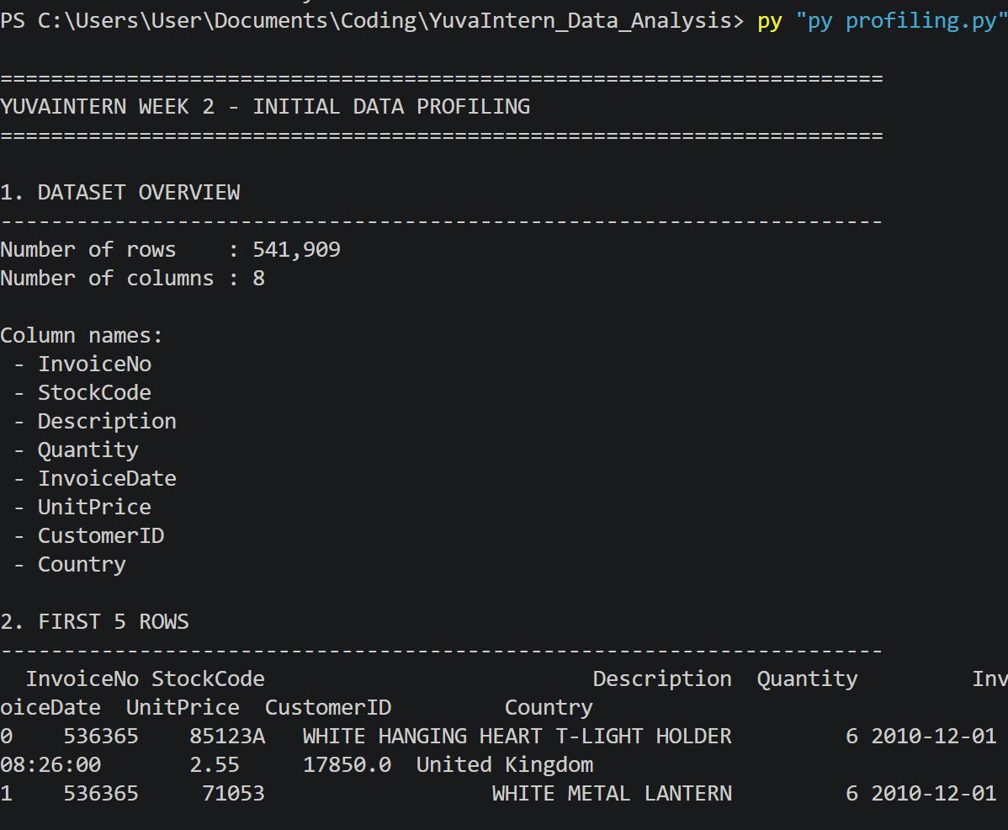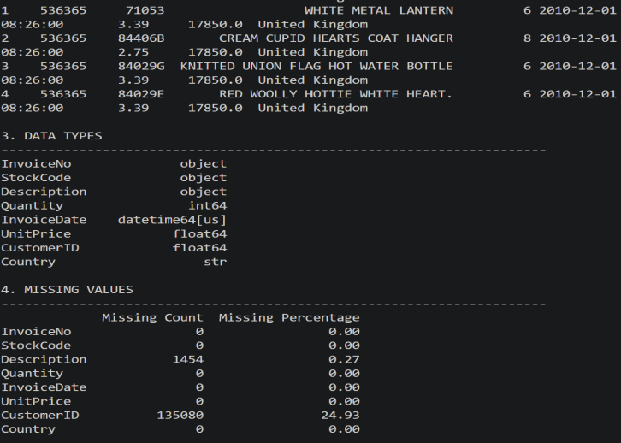

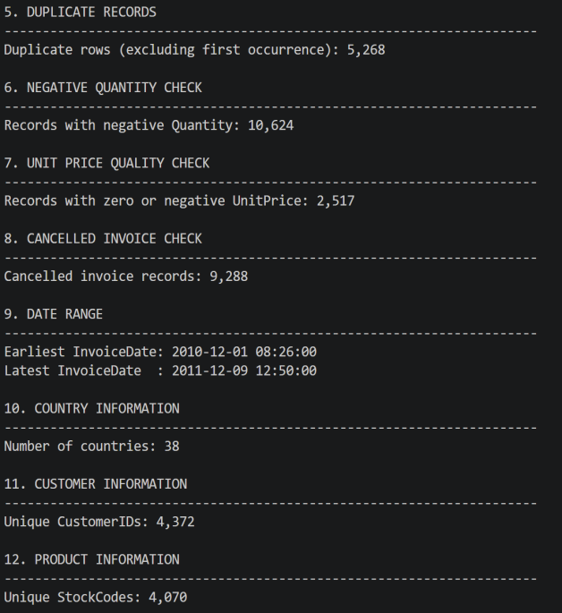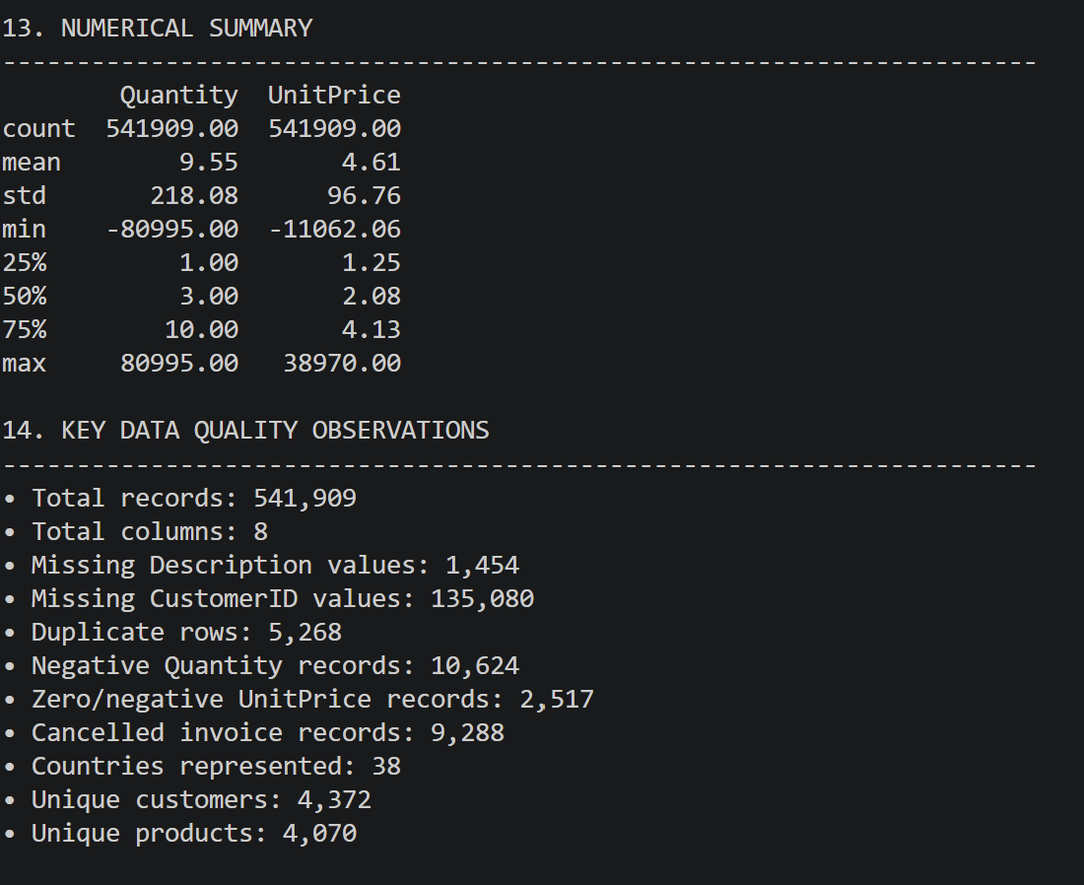

Fig 1: Initital Dataset Profiling

4. Data Quality Issues Identified

Several important quality issues were identified during profiling.

4.1 Duplicate Records

The dataset contained 5,268 exact duplicate rows.

Duplicate records can cause transactions to be counted more than once and can therefore distort sales totals, product performance and customer analysis.

These exact duplicate rows were removed during cleaning.

4.2 Cancelled Invoices

There were 9,288 records associated with cancelled invoices.

In the dataset, invoice numbers beginning with the letter "C" indicate cancellations.

These records were removed from the main sales-analysis dataset because the objective is to analyze completed sales rather than cancelled transactions.

4.3 Negative Quantities

The dataset contained 10,624 records with negative quantities.

Negative quantities can represent returned or cancelled products rather than normal sales. For the primary sales-analysis dataset, records with non-positive quantities were excluded.

However, these records were treated as a data-quality/business-event issue rather than simply being considered meaningless data.

4.4 Zero or Negative Unit Prices

There were 2,517 records with zero or negative unit prices.

Such values are unsuitable for calculating normal sales revenue because a normal completed sale should have a positive selling price.

Therefore, records with non-positive UnitPrice values were excluded from the main cleaned sales dataset.

4.5 Missing Customer IDs

A total of 135,080 CustomerID values were missing in the original dataset.

CustomerID values were not artificially imputed because a customer identifier cannot reliably be calculated from other columns.

Transactions without CustomerID can still be useful for overall transaction and sales analysis, but they cannot be reliably assigned to an individual customer for customer-level analysis.

5. Data Cleaning Process

The cleaning process was performed using Python and Pandas.

Step 1: Remove Exact Duplicates

The first cleaning step removed exact duplicate rows.

Before cleaning:

541,909 records

After removing duplicates:

536,641 records

Therefore:

5,268 duplicate records were removed.

Step 2: Remove Cancelled Invoices

Records associated with cancelled invoices were removed from the main sales dataset.

After removing cancelled invoices:

527,390 records remained.

Step 3: Remove Non-Positive Quantities

Records where Quantity was zero or negative were removed.

After this step:

526,054 records remained.

Step 4: Remove Non-Positive Prices

Records where UnitPrice was zero or negative were removed.

After this step:

524,878 records remained.

Step 5: Handle Missing Descriptions

Missing product descriptions were replaced with:

"Unknown Product"

This avoids leaving blank product descriptions in the cleaned dataset while clearly identifying records where the original description was unavailable.

Step 6: Standardize Text Fields

The following text fields were stripped of unnecessary leading and trailing spaces:

- InvoiceNo
- StockCode
- Description
- Country

This helps prevent inconsistent text values caused by accidental spaces.

Step 7: Convert Data Types

The following data-type conversions were performed:

- InvoiceNo → string
- StockCode → string
- Quantity → numeric
- UnitPrice → numeric
- CustomerID → numeric
- InvoiceDate → datetime

This ensures that numerical calculations and date-based analysis can be performed correctly.

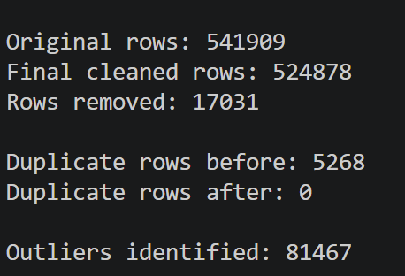

Fig 2: Python output showing the completed data cleaning process

6. Before-and-After Cleaning Snapshot

The following table summarizes the major changes:

Data Quality Measure| Before Cleaning| After Cleaning
Total records| 541,909| 524,878
Exact duplicate rows| 5,268| 0
Cancelled invoices| 9,288| Removed from sales dataset
Negative/non-positive quantities| 10,624| Removed from sales dataset
Zero/negative prices| 2,517| Removed from sales dataset
Missing Description| 1,454| Replaced with "Unknown Product"
Missing CustomerID| 135,080| Retained where unavailable

The final cleaned dataset contained 524,878 records and 18 columns, including newly created analytical features.

7. Feature Engineering

Additional features were created to make the dataset more useful for future analysis.

7.1 Revenue

A new Revenue column was created using:

Revenue = Quantity × UnitPrice

This variable will be useful for calculating total sales, product revenue and customer spending.

7.2 Date Features

The original InvoiceDate field was used to create:

- Year
- Month
- Month Name
- Day
- Day of Week

These variables will support future time-based sales analysis.

For example, they can be used to investigate monthly sales patterns, weekday sales and yearly trends.

8. Outlier Detection

Outliers were identified using the Interquartile Range (IQR) method.

The IQR method uses the first quartile (Q1), third quartile (Q3) and the interquartile range:

IQR = Q3 − Q1

The normal range was calculated using:

Lower Bound = Q1 − 1.5 × IQR

Upper Bound = Q3 + 1.5 × IQR

Outlier detection was performed for:

- Quantity
- UnitPrice
- Revenue

The analysis identified 81,467 records as outliers based on at least one of these measures.

The outliers were flagged rather than automatically deleted.

This decision was important because some unusually large quantities may represent genuine wholesale purchases. Automatically removing every statistical outlier could therefore remove legitimate business information.

Three outlier indicators were created:

- Quantity_Outlier
- UnitPrice_Outlier
- Revenue_Outlier

A combined "Is_Outlier" field was also created.

9. Normalization

Normalization was performed for the model-ready dataset.

The following numerical variables were normalized:

- Quantity
- UnitPrice
- Revenue

The Min-Max Scaling technique was used.

The general formula is:

Normalized Value = (X − Xmin) / (Xmax − Xmin)

This transforms numerical values to a common scale between 0 and 1.

Normalization can be useful for statistical and machine-learning methods where variables with different numerical scales could otherwise have an unequal influence.

The original values were retained in the main cleaned dataset so that business calculations such as revenue remain interpretable.

10. Categorical Data Encoding

The "Country" column is categorical and contains country names rather than numerical values.

For the model-ready dataset, the Country variable was converted using one-hot encoding.

One-hot encoding creates separate binary variables for the different categories.

For example, a country variable can be represented as:

Country| Country_UK| Country_France| Country_Germany
UK| 1| 0| 0
France| 0| 1| 0
Germany| 0| 0| 1

This makes categorical information suitable for algorithms that require numerical input.

CustomerID was not treated as a continuous numerical variable because it represents an identifier rather than a measurable quantity.

11. Final Data Validation

After cleaning, several validation checks were performed.

The final cleaned dataset contained:

- 524,878 rows
- 18 columns
- 0 duplicate rows

The final dataset contained no missing values in:

- InvoiceNo
- StockCode
- Description
- Quantity
- InvoiceDate
- UnitPrice
- Country
- Revenue
- Derived date fields
- Outlier flags

CustomerID remained missing for 132,186 records because these customers were not identified in the original dataset.

These missing CustomerID values were intentionally retained instead of being artificially assigned.

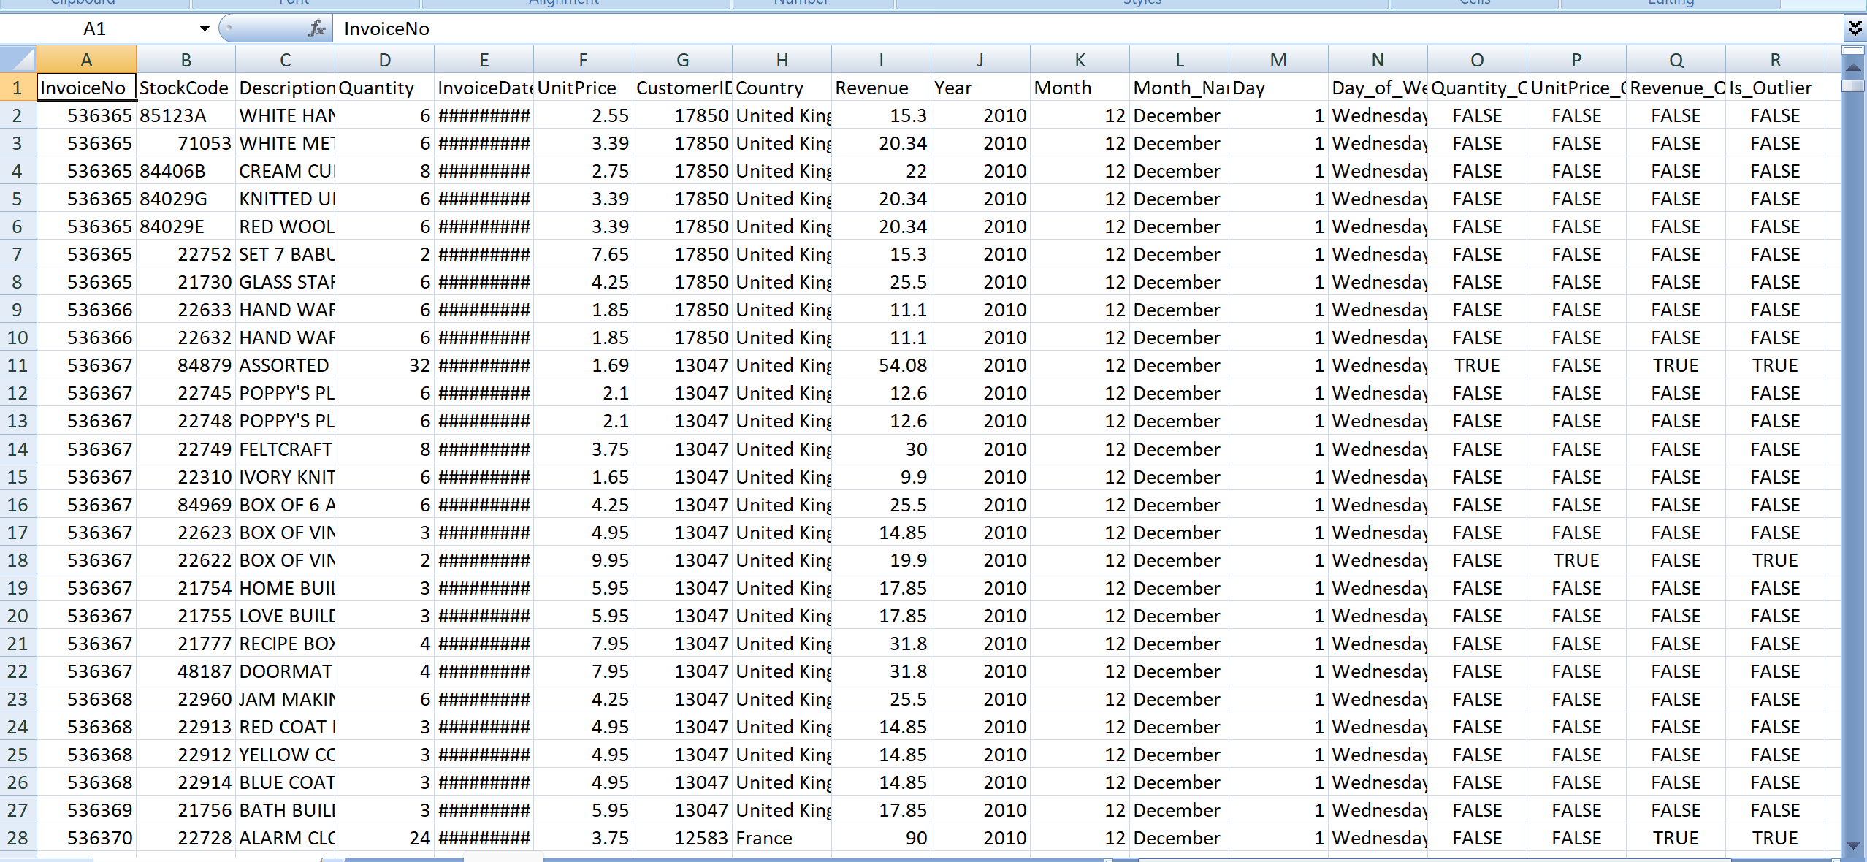

Fig 3: Sample of the final cleaned dataset

12. Challenges and Solutions

Challenge 1: Duplicate Transactions

Duplicate records could result in over-counting sales.

Solution: Exact duplicate rows were identified and removed.

Challenge 2: Cancelled Transactions

Cancelled invoices could distort completed-sales analysis.

Solution: Invoice numbers beginning with "C" were identified and removed from the main sales-analysis dataset.

Challenge 3: Negative Quantities

Negative quantities can represent returns or cancellations.

Solution: Non-positive quantities were excluded from the main sales dataset while recognizing that such transactions may represent legitimate business events.

Challenge 4: Non-Positive Prices

Zero or negative prices are unsuitable for normal sales revenue calculations.

Solution: Records with non-positive UnitPrice values were excluded from the main sales-analysis dataset.

Challenge 5: Missing Customer IDs

A large number of transactions did not contain CustomerID values.

Solution: CustomerID values were not artificially created. Such transactions can still be used for overall sales analysis, while customer-level analysis will use records with known CustomerIDs.

Challenge 6: Extreme Values

Large quantities and prices generated many statistical outliers.

Solution: Outliers were flagged using the IQR method instead of automatically deleting them, because some extreme transactions may represent genuine wholesale activity.

13. Legal and Ethical Considerations

The dataset was obtained from the publicly available UCI Machine Learning Repository.

The dataset should be used according to its stated license and attribution requirements.

From an ethical perspective, customer identifiers should not be used to attempt to identify individual people. Missing customer information should not be artificially reconstructed.

The analysis should focus on legitimate business and analytical purposes. Results should be reported accurately without intentionally manipulating the data to produce a desired conclusion.

The original dataset was preserved separately from the cleaned dataset to maintain data traceability and reproducibility.

14. Tools and Technologies Used

The following tools were used during the data acquisition and cleaning process:

Tool/Technology| Purpose
Python| Data processing
Pandas| Data loading, profiling and cleaning
NumPy| Numerical operations
Scikit-learn| Data normalization
OpenPyXL| Excel file processing
VS Code| Python development environment
UCI Repository| Dataset source
GitHub| Project version control

15. Output Files

The following files were generated after processing the dataset:

"online_retail_cleaned.csv"

This is the main cleaned transaction dataset containing the cleaned records, revenue features, date features and outlier indicators.

"online_retail_model_ready.csv"

This dataset contains normalized numerical features and one-hot encoded country variables for potential future statistical or machine-learning analysis.

"week2_results.txt"

This file contains the actual profiling, cleaning and validation results generated by the Python program.

16. Conclusion

The Week 2 data acquisition and cleaning process successfully transformed the original Online Retail dataset into a more consistent and analysis-ready dataset.

The original dataset contained 541,909 records. After removing exact duplicates, cancelled transactions, non-positive quantities and non-positive prices, the final cleaned dataset contained 524,878 records.

The process also handled missing descriptions, standardized text fields, converted data types, created revenue and date-based features, detected statistical outliers, normalized numerical variables and encoded categorical information.

The cleaning process was designed to preserve important business information while preventing invalid records from affecting the main sales analysis. In particular, outliers were flagged rather than automatically removed, and missing CustomerID values were retained instead of being artificially assigned.

The resulting cleaned dataset provides a reliable foundation for the next stages of the project, including exploratory data analysis, visualization, statistical analysis and dashboard development.

17. References

1. UCI Machine Learning Repository. Online Retail Dataset.
https://archive.ics.uci.edu/dataset/352/online+retail

2. Pandas Documentation. Pandas – Python Data Analysis Library.
https://pandas.pydata.org/

3. Scikit-learn Documentation. Preprocessing and Scaling Features.
https://scikit-learn.org/

4. Python Documentation. Python Programming Language.
https://www.python.org/

